TrendMeLeaveMe is a MetaTrader 5 EA. The semi-automated Expert Advisor using a trend line (TrendLIne).
Before launching the EA, simply draw a bullish or a bearish trend. Set the properties, launch the EA and you are free to focus your attention on something else.
This is an automated EA. First, you should draw an upward, downward or horizontal trend:
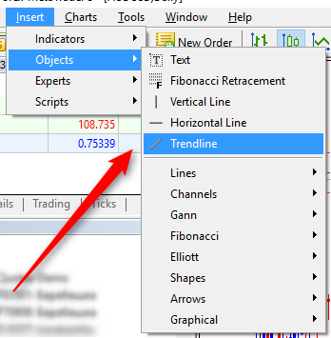
Name it buystop or sellstop and set the BuyStop_StepUpper, BuyStop_StepLower, SellStop_StepUpper and SellStop_StepLower parameters
When the price enters the area between your buystop and BuyStop_StepLower levels, the EA opens a buystop order following the BuyStop_StepUpper price. When the price enters the area between your sellstop and SellStop_StepUpper levels, the EA opens a sellstop order following the SellStop_StepLower price.
The EA always changes the OpenPrice for both order types when the price follows a trend till it leaves the displayed area.
You can adjust BuyStop_StopLoss , BuyStop_Takeprofit and BuyStop_Lot to open a buystop order. You can also set SellStop_StopLoss, SellStop_Takeprofit and SellStop_Lot for a sellstop order.
Here is how it looks on the charts:
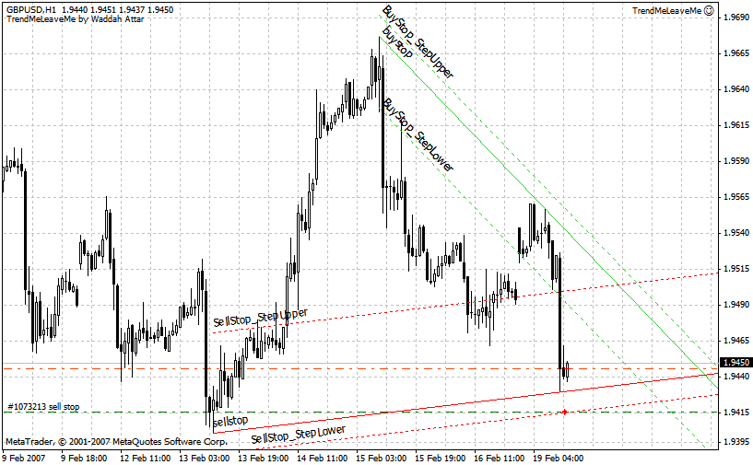
Another example:
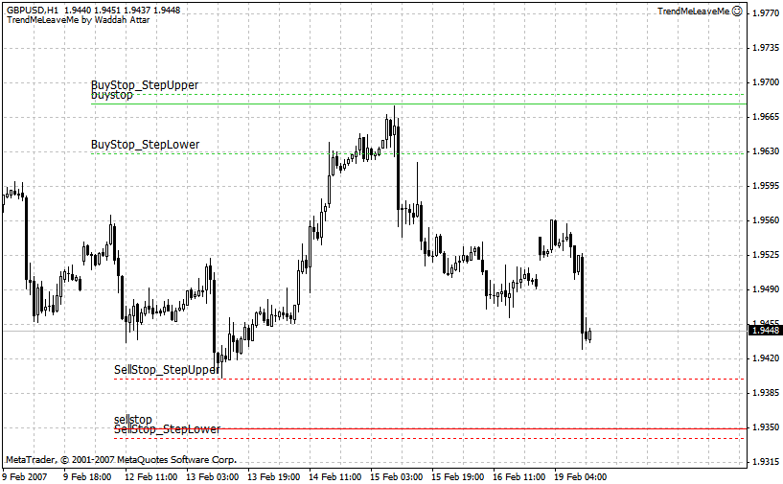

Transla

